Tracie Scott & Vinh Le
Project III, Section 404 – Experimental Statistics II

Background
The project data is the Open University Learning Analytics Dataset (OULAD) listed on the University of California, Irvine, (UCI), Machine Learning site https://archive.ics.uci.edu/ml/datasets.html. OULAD contains data for seven selected courses, the students registered for the courses, and the students’ interactions with Virtual Learning Environment (VLE) for those courses.

More information, examples and news can be found at: [Web Link]. This dataset is released under CC-BY 4.0 license. Citation request is Kuzilek, J., Hlosta, M., Herrmannova, D., Zdrahal, Z. and Wolff, A. OU Analyse: Analysing At-Risk Students at The Open University. Learning Analytics Review, no. LAK15-1, March 2015, ISSN: 2057-7494.

Question of interest
Using the data available in the data set and cluster analysis,
- Can we identify clusters of participants that are more likely to succeed within the first year of education using the Open University? (Phase 1)
- Further, can we identify study habits or patterns that enhance the probability of success? (Phase 2)
Performance is determined by the final result of the student’s effort and is characterized by completing the module/term with a passing score, either with or without Distinction.

Description of Project Data
This project leverages the anonymized Open University Learning Analytics Dataset (OULAD). The data set contains data about courses and students as well as the students’ interactions with the Virtual Learning Environment (VLE) for seven selected courses (called modules). The data represents a small slice of time for a very limited number of courses (7).

As students can register for multiple classes, there can be several rows for one student related to different modules or different presentations of the same modules. To minimize the time-series nature of the data, all repeat attempts by a student for a module were removed. Only data associated with students whose highest level of education as below “HE Qualification” (aka Freshmen) at the time of module registration were retained in the analysis. No attempt was made to eliminate student repetition across in multiple modules as a visual review of the data indicated few instances of participation by one student in multiple modules in the remaining data.

While there are seven data sets comprising OULAD, only two data sets were referenced in the analysis. The “studentInfo” dataset, containing demographic and personal information for each student was used in the cluster analysis to identify groups of students more likely to succeed in Open University modules. The “studentVle” dataset contained records of all on-line activity for each student within the VLE. The data set was collapsed to provide summary statistics for student activity and merged with the ‘studentInfo’ data. The resulting data set was used to look for study habits or patterns of usage that lead to a greater propensity for program success. The Appendix contains a schema for the data set. Otherwise refer to the link in the introduction for more detailed information about OULAD.

Description of Project Approach
This project followed a five step approach that was outlined in scholarly papers (1). Research will be presented according to this methodology:
- Review the data. Address obvious data challenges. For example, categorical variables are not suitable for cluster analysis. Make pair wise scatter plots to look for multicollinearity, outliers, cluster shapes, unexpected data values and other issues that may need to be addressed.
- Perform data transformations. Data with poorly separated or elongated patterns need to be transformed. Also, variables with different units of measurement or with different size variances will need to be transformed as well.
- Perform the cluster analysis calculations. Based on the nature of the data, the researcher must select the best distance measure and method of cluster analysis to perform.
- Determine the number of clusters to use in the cluster analysis. This project used two methods to identify the number of clusters:
  - Using R-squared as a guide, select the minimal number of clusters that best accounts for the variability within the data set
  - Calculate and review metrics that assist with cluster selection: Cubic Clustering Criterion (CCC), Pseudo F and the T Squared.
- Validate the clusters. Compare statistics for the putative clusters. Based on diagnostics (in terms of statistics) and verification process (in terms of subject matter), do the clusters make sense?

Approach
- Review the data
studentInfo.csv – the first phase of analysis was performed on this data:
This file contains demographic information about the student when registering for a module together with their result for the model. The csv file contains the following columns. Note that most fields are categorical, so the data was transformed into dummy or ordinal data as input into the analysis. Most fields, like gender and age, only have a limited number of values. Data modifications are presented for each field.
- code_module – an identification code for a module for which the student is registered (at SMU, this would be a “section”, like Experimental Statistics 402). Used for data identification (key value) only. This code has been anonymized and there is no information concerning the subject matter or difficulty of the module.
- code_presentation - the identification code of the presentation during which the student is registered for the module (at SMU, this would be a school term, like “Spring 2017”). Used for identification (key value) only. It consists of the year and “B” for the presentation starting in February and “J” for the presentation starting in October.
- id_student – a unique identification number for the student. Used for identification (key value) only. Note: The above three fields were concatenated into a single field to create a unique identifier joining the student to the student’s study activities.
- gender – the student’s gender
male | 0 |  | included
Female | 1 | incldued
- region – identifies the geographic region, where the student lived while taking the module-presentation. Not included in the analysis.
- highest_education – highest student education level on entry to the module presentation.
No Formal quals (qualification) | 0 | Included
Lower Than A Level | 1 | Included
A Level or Equivalent | 2 | Included
HE Qualification | 3 | Excluded from research
Post Graduate Qualification | 4 | Excluded from research
- imd_band – specifies the Index of Multiple Depravation band of the place where the student lived during the module-presentation. The higher the number, the more challenged the location for resources.
0-10% | 10 | Included
10-20% | 20 | Included
20-30% | 30 | Included
30-40% | 40 | Included
40-50% | 50 | Included
50-60% | 60 | Included
60-70% | 70 | Included
70-80% | 80 | Included
80-90% | 90 | Included
90-100% | 100 | Included
- age_band – band of the student’s age. The oldest band was not included in the analysis as there were so few in that band as to be considered outliers.
0-35 | 0 | Included
35-55 | 1 | Included
55<= | 2 | Excluded from research
- num_of_prev_attempts – the number times the student has attempted this module at time of registration. Rows with values > 0 were excluded from the analysis.
- studied_credits – the total number of credits for the modules the student is currently studying. This field contained unexpected large values and was excluded from the final analysis. More information about this field is needed if further research is performed on this data.
- disability – indicates whether the student has declared a disability.
No disability declared | 0 |  | included
Disability declared | 1 | included
- final_result – student’s final result in the module-presentation.
Withdraw | 0 | Included
Fail | 1 | Included
Pass | 2 | Included
Distinction | 3 | Included
The table below presents few sample records from the original dataset:
The data reflects the 2013 2014 academic years. To limit the time-series nature of the data, this research focused on students in the first year of advanced education by including only students with highest-education below “HE Qualification”. This should limit the research to ‘freshmen’ students. The data was also limited to initial attempts to each modules. All records that indicated a prior attempt for a module were excluded.
studentVle.csv
The studentVle.csv file contains information about each student’s interactions with the materials in the Virtual Learning Environment (VLE). This file contains the following columns:
- code_module – an identification code for a module.
- code_presentation - the identification code of the module presentation.
- id_student – a unique identification number for the student. The above three fields were concatenated into a single field to create a unique identifier joining the student to the student’s study activities.
- id_site - an identification number for the VLE material. There are many different types of materials, such as oucontent, ouwiki, url, forumng, etc…, and zero to many instances of each type for each module.
- date – the date of student’s interaction with the material measured as the number of days since the start of the module-presentation. Represented as an integer value and can be negative if the material is accessed before the start of the presentation.
- sum_click – the number of times a student interacts with the material in that day.
The table below presents few sample records from the original dataset:
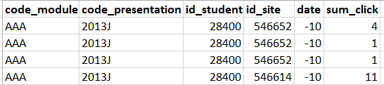
For phase 2 of the effort, identifying study habits that lead to success, this data was collapsed to a single row for each module/presentation/student and the following metrics were calculated and appended to the studentInfo information.
- Cntresource - number of unique resources accessed for a presentation
- CntActivities - count of unique study events (resource / day)
- SumAllClicks - total number of clicks for all activities in the presentation
- SumClicks30 - clicks within the first 30 days of the presentations
- EarlyAccess - earliest day of study activity for the presentation (integer value, may be negative if precedes first day of presentation)
Phase 2 of the analysis used these metrics along with FinalResult from StudentInfo to cluster study habits and the final result of the student’s effort in the module.
Once data was translated as indicated, scatter charts of the data were examined. To save space, they are not presented in the paper. The scatter charts indicated elongated clusters for both Phases. Phase 1 did not present with outliers. Phase 2 presented with outliers, which are detrimental to cluster analysis. Rows with extreme outliers were eliminated from Phase 2 research. Rows were eliminated if any of the following thresholds were exceeded.
- Count of unique resources over 380
- Early Access (first day course materials were referenced) over 150
- Sum of all clicks exceeded 20,000
- Clicks within the first 30 days of the presentation exceeded 4,000
Even with these efforts to eliminate obvious outliers, the CCC output for Phase 2 indicated the final clusters were impacted by outliers.

- Performing data transformation
Because the variables in the data set are on different scales and do not have equal variance, some form of scaling or transformation is required. One method is to standardize the variables to mean zero and variance one. However, when it’s suspected that the data contain elliptical clusters, the ACECLUS procedure transforms the data such that the resulting within-cluster covariance matrix is spherical. The procedure obtains approximate estimates of the pooled within-cluster covariance matrix and then computes canonical variables to be used in subsequent analyses.(2) Reviewing pairwise scatter plots for the variables in Phase 1 and Phase 2 suggest elongated clusters, so the ACECLUS procedure was selected as the transformation method for the analysis and the canonical values calculated by ACECLUS were passed to PROC CLUSTER.

- Perform the cluster analysis
With no assumptions about how many clusters may exist in the data and with a reasonable amount of data, the research performed agglomerative hierarchical clustering of observations with PROC CLUSTER using Ward’s method.
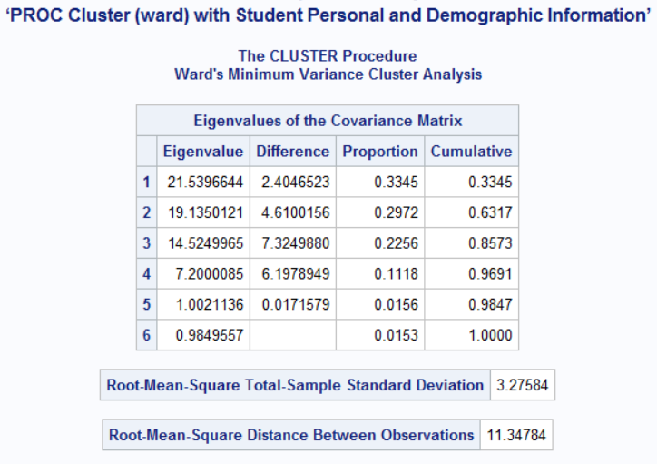
Phase 1 results – Student demographics

Both the root mean square stand deviation (3.3) and the root mean square distance between observations (11.3) are relatively small.
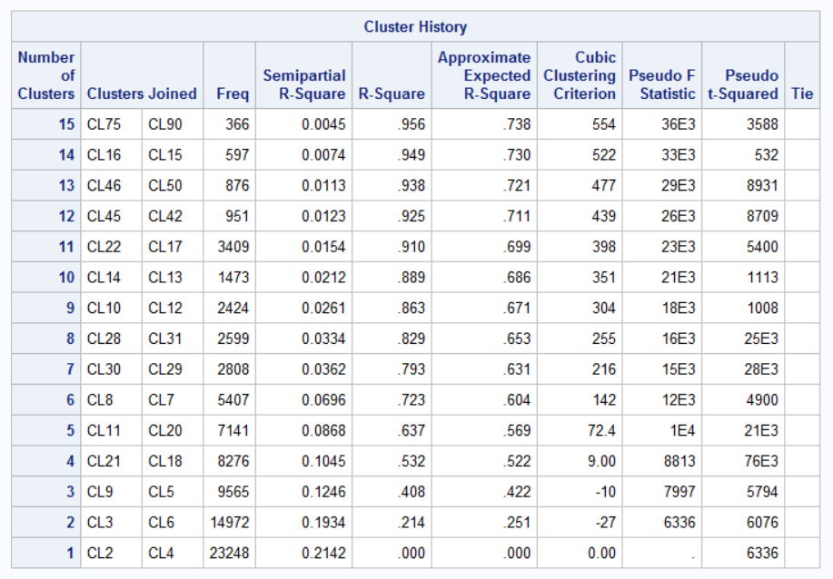
(Both are smaller than the Woodyard Hammock example from Unit 13.)

R-Square values from cluster history reflects the proportion of variance accounted for by the clusters. Almost 80% of variability is explained by seven (7) clusters.
The approximate expected value of R square is given in the ERSQ column. This expectation is approximated under the null hypothesis that the data have a uniform distribution instead of forming distinct clusters.
The graph below plots the three statistics for estimating the number of clusters.
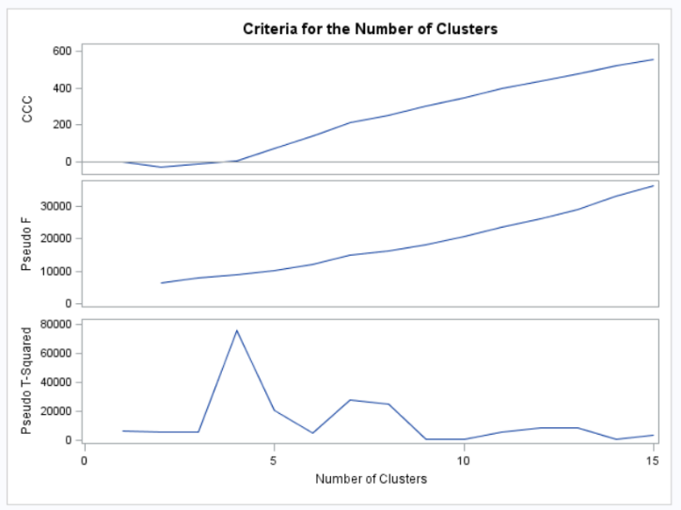
- Determine the number of clusters to use in the cluster analysis.
Reviewing the Cluster History and the charts, seven (7) was selected as the number of clusters. The most prominent ‘peak’ across all three statistics occurs at seven and seven clusters explains almost 80% as the variability in the data.
A tree diagram is presented in the Appendix for the seven clusters. Given the large number of observations, it’s not particularly illuminating.
Phase 2 results – Study Habits
A similar approach was used for data transformation and cluster analysis for the Study Habit data. Associated charts and a tree diagram are available in the Appendix. Both the root mean square standard deviation (3) and the root mean square distance between observations (10.3) are relatively small. That effort resulted in four clusters being selected.
Note: An ‘ubber’ analysis was attempted combining the student demographics and the study habits, but the resulting cluster history revealed that even with ten (10) clusters less than half of the data variability was explained. That analysis was deferred.
- Validate the Clusters
The final computational step is to determine if the data represented by the clusters has a uniform distribution in the data set or if there are identifiable clusters. For both Phase 1 and Phase 2, the null hypothesis is that that the data have a uniform distribution instead of forming distinct clusters.
Phase 1 results – Student demographics
Using PROC GLM with the resulting seven clusters and the original variables, the p-value for each variable was statistically significant (p-value < .0001 for all variables) at a 95% confidence level. A PROC GLM was also applied to the cluster number and the canonical values used in the cluster analysis and each of those was also statistically significant at a 95% confidence level. Thus, we reject the null hypothesis that the data for these variables are uniformly distributed across the data set. Functionally, this indicates the variables investigated do not have a uniform distribution in the data and form distinct clusters that may be helpful for understanding the association between student demographics and module outcome.
Phase 2 results – Study Habits
Using PROC GLM with the resulting four clusters and the original variables, the p-value for each variable was statistically significant (p-value < .0001 for all variables) at a 95% confidence level. Again, we reject the null hypothesis that the data for these variables are uniformly distributed across the data set. Functionally, this indicates the variables investigated do not have a uniform distribution in the data and form distinct clusters that may be helpful for understanding the association between student study habits and module outcome.

Conclusion
Note that cluster analysis is exploratory in nature, and having different clusters across a variable, such as FinalResult, does not prove that each cluster has a statistically different value for that variable than all other clusters. Thus we cannot assert that any one cluster of students has a statistically better outcome (FinalResult) than any other cluster based solely on this research. With that said, the chart below presents the FinalResult variable across the seven demographic clusters.
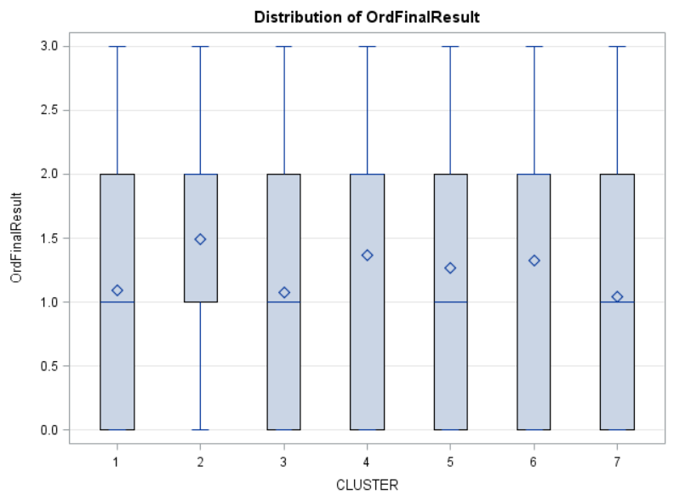
This indicates that some clusters have a higher mean for FinalResult than others. As a reminder, FinalResult is an ordinal value with the following values:
- Withdraw 0
- Fail 1
- Pass 2
- Distinction 3
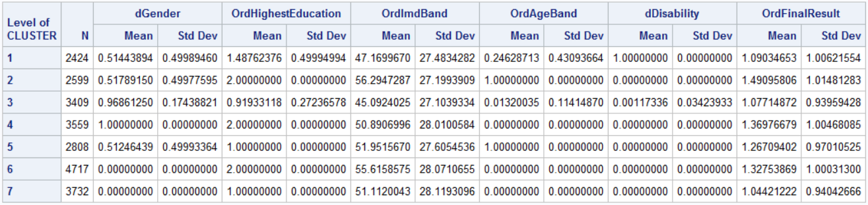
All clusters, on average, Pass the modules, all have members who exit with Distinction, and Pass (2) is the 75th percentile.
Who comprise the clusters?
Clusters reflect mixtures of demographics, but in general, in order of highest to lowest mean FinalResult:
Cluster 2 – Male or Female students who are between 35 and 55 years of age with highest education of ‘Equivalent to A levels’.
Cluster 4 – Female students who are between 0 and 35 years of age with highest education of ‘Equivalent to A levels’.
Cluster 6 – Males students who are between 0 and 35 years of age with highest education of ‘Equivalent to A levels’.
Cluster 5 – Males and Females between 35 and 55 with highest education ‘Lower than A Level’.
Cluster 1 - Contains students who reported Disabilities.
Cluster 3 – Females between 0 and 35 with highest education ‘Lower than A Level’.
Cluster 7 – Males between 0 and 35 with highest education ‘Lower than A Level’.
This research suggest that students in Clusters 1, 3, and 7 would benefit from intervention, additional resources, or alternate approaches to bring their average score into alignment with the other clusters.
Reviewing the results of the Study Habits research yielded no surprises. The earlier the effort and the more effort, the better the outcome.
Cluster 1 barely averaged only a bit above Fail (1). Effort metrics are markedly lower than other clusters.
Cluster 2 and Cluster 3 averaged just above a Pass (2) score, but Cluster 3 expended far more effort than Cluster 2.
Cluster 4 scored well as a large portion passed with Distinction, but their level of effort also far exceeded the other clusters.
This data needs more refined analysis to yield telling results, but some patterns are evident.
- Reviewing presentation materials 12 to 14 days before class starts, but minimally a week beforehand (standard deviation of 5 days), contributes to better outcomes.
- In the first 30 days, clusters who averaged over 2 had almost as many clicks (664) to upwards of 4x the number of clicks (2800) than Cluster 1 had in the entire presentation (746).
- On the other hand, while each cluster represents a marked increase in effort, there is only .1 difference in FinalResult between Cluster 1 and Cluster 2 and only .3 difference between Cluster 3 and Cluster 4, indicating there may be a point of diminishing return.
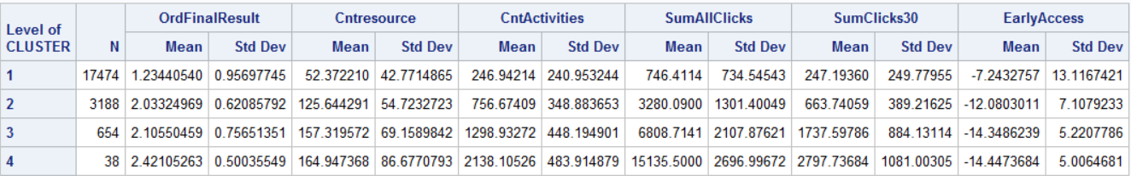
Additional References
- http://analytics.ncsu.edu/sesug/2007/DM05.pdf - Paper DM05 A METHODOLOGICAL APPROACH TO PERFORMING CLUSTER ANALYSIS WITH SAS® William F. McCarthy Maryland Medical Research Institute, Baltimore, MD
- https://support.sas.com/documentation/cdl/en/statug/63033/HTML/default/viewer.htm#statug_cluster_sect002.htm, - SAS/STAT 9.2 Users Guiide, Second edition

Appendix

Code
libname MYSASLIB "\\Client\C$\Users\User\Documents\Course Exp Stats II\Project III\MYDATA";
/* DATA STEP. */
/* Student Interaction with VLE (Virtual Learning Environment */
Data RawStudentVle;
infile "\\Client\C$\Users\User\Documents\Course Exp Stats II\Project III\OULAD\studentVle.csv" dlm="," dsd firstobs=2;
input CodeModule $ CodePresentation $ IdStudent $ IdSite $ TermDayIn $ SumClickIn $;
run; quit;
proc print data=RawStudentVle (obs=40);
Title 'Project III - Experimental Statistics II';
Title2 'Tracie Scott - Section 404';
Title3 'Data: Open University';
Title4 'Student Behavior - VLE Interaction';
run; quit;
data StudentVle;
set RawStudentVle;
format ModPresStudent $20.;
ModPresStudent = catx("-", of CodeModule CodePresentation IdStudent);
if TermDayIn EQ "?" then TermDay = .;
else TermDay = input(TermDayIn,4.00);
if SumClickIn EQ "?" then SumClick = .;
else SumClick = input(SumClickIn,4.00);
Drop TermDayIn SumClickIn;
run;quit;

proc sort DATA=StudentVle OUT=sortedStuVle;
BY ModPresStudent IdSite;
run;

proc print data=sortedStuVle (obs=40);
Title 'Project III - Experimental Statistics II';
Title2 'Tracie Scott - Section 404';
Title3 'Data: Open University';
Title4 'Student Behavior - VLE Interaction Updated';
run; quit;

DATA StudyMetrics;
SET sortedStuVle;
BY ModPresStudent;
format ResourceID $6.;
RETAIN ResourceID Cntresource CntActivities SumAllClicks SumClicks30 EarlyAccess;
IF first.ModPresStudent THEN
DO; /* reset variables */
ResourceID = '999999'; /* last resource */
Cntresource = 0; /* resources accessed */
CntActivities = 0; /* count of study days */
SumAllClicks = 0; /* total number of clicks */
SumClicks30 = 0; /* clicks first 30 days */
EarlyAccess = 9999; /* earliest day of study */
END;
CntActivities = CntActivities + 1;
SumAllClicks = SumAllClicks + SumClick;

If IdSite NE ResourceID then
Do;
Cntresource = Cntresource + 1;
ResourceID = IdSite;
End;

If TermDay LE 30 then
SumClicks30 = SumClicks30 + SumClick;

If TermDay LT EarlyAccess then
EarlyAccess = TermDay;

/* this outputs a record ONLY when at the last obs*/;
IF last.ModPresStudent THEN
DO;
OUTPUT;
END;

KEEP ModPresStudent Cntresource CntActivities SumAllClicks SumClicks30 EarlyAccess;
RUN; QUIT;

proc sort DATA=StudyMetrics OUT=sortedStudyMetrics;
BY ModPresStudent;
run;

/* Student Personal and Demographic Information */
Data RawStudentInfo;
infile "\\Client\C$\Users\User\Documents\Course Exp Stats II\Project III\OULAD\studentInfo.csv" dlm="," dsd firstobs=2;
format CodeModule $3.;
format CodePresentation $5.;
format IdStudent $8.;
format Region $25.;
format HighestEducation $30.;
format FinalResult $15.;
input CodeModule $ CodePresentation $ IdStudent $ Gender $ Region $ HighestEducation $ ImdBand $ AgeBand $ NumPrevAttemptsIn $ StudiedCreditsIn $ Disability $ FinalResult $;
run; quit;

proc print data=RawStudentInfo (obs=40);
Title 'Project III - Experimental Statistics II';
Title2 'Tracie Scott - Section 404';
Title3 'Data: Open University';
Title4 'Student Personal and Demographic Information';
run; quit;

data StudentInfo;
set RawStudentInfo;
ident = _n_;
format ModPresStudent $20.;
ModPresStudent = catx("-", of CodeModule CodePresentation IdStudent);
/* set character values to numerics as needed */
if NumPrevAttemptsIn EQ "?" then NumPrevAttempts = .;
else NumPrevAttempts = input(NumPrevAttemptsIn,4.00);
if StudiedCreditsIn EQ "?" then StudiedCredits = .;
else StudiedCredits = input(StudiedCreditsIn,4.00);
/* transform charactor factors to dummy or ordinal values where possible */
if Gender EQ "?" then dGender = .;
else if Gender EQ "M" then dGender = 0;
else dgender = 1;
if Disability EQ "?" then dDisability = .;
else if Disability EQ "N" then dDisability = 0;
else dDisability = 1;
if FinalResult EQ "?" then OrdFinalResult = .;
else if FinalResult EQ "Withdrawn" then OrdFinalResult = 0;
else if FinalResult EQ "Fail" then OrdFinalResult = 1;
else if FinalResult EQ "Pass" then OrdFinalResult = 2;
else if FinalResult EQ "Distinction" then OrdFinalResult = 3;

if HighestEducation EQ "?" then OrdHighestEducation = .;
else if HighestEducation EQ "No Formal quals" then OrdHighestEducation = 0;
else if HighestEducation EQ "Lower Than A Level" then OrdHighestEducation = 1;
else if HighestEducation EQ "A Level or Equivalent" then OrdHighestEducation = 2;
else if HighestEducation EQ "HE Qualification" then OrdHighestEducation = 3;
else if HighestEducation EQ "Post Graduate Qualification" then OrdHighestEducation = 4;

if Imdband EQ "?" then OrdImdBand = .;
else if Imdband EQ "0-10%" then OrdImdBand = 10;
else if Imdband EQ "10-20" then OrdImdBand = 20;
else if Imdband EQ "20-30%" then OrdImdBand = 30;
else if Imdband EQ "30-40%" then OrdImdBand = 40;
else if Imdband EQ "40-50%" then OrdImdBand = 50;
else if Imdband EQ "50-60%" then OrdImdBand = 60;
else if Imdband EQ "60-70%" then OrdImdBand = 70;
else if Imdband EQ "70-80%" then OrdImdBand = 80;
else if Imdband EQ "80-90%" then OrdImdBand = 90;
else if Imdband EQ "90-100%" then OrdImdBand = 100;

if AgeBand EQ "?" then OrdAgeBand = .;
else if AgeBand EQ "0-35" then OrdAgeBand = 0;
else if AgeBand EQ "35-55" then OrdAgeBand = 1;
else if AgeBand EQ "55<=" then OrdAgeBand = 2;
/* reduce variability in the data by eliminating data not in the population of interest */
if NumPrevAttempts GT 0 then delete;
if OrdHighestEducation GT 2 then delete;
if OrdAgeBand GT 1 then delete;
/*Drop StudiedCreditsIn NumPrevAttemptsIn;*/
run;quit;

proc print data=StudentInfo (obs=40);
Title 'Project III - Experimental Statistics II';
Title2 'Tracie Scott - Section 404';
Title3 'Data: Open University';
Title4 'Student Personal and Demographic Information Updated';
run; quit;

proc sort; by ident; run; quit

proc sgscatter data=StudentInfo;
title4 "Exploring PairWise Relationships within StudentInfo";
matrix dGender OrdHighestEducation OrdImdBand OrdAgeBand StudiedCredits dDisability OrdFinalResult;
run; quit;

/* eliminate Studied Credits */

proc aceclus data=StudentInfo out=Ace p=.03 noprint;
var dGender OrdHighestEducation OrdImdBand OrdAgeBand dDisability OrdFinalResult;
title4 'PROC ACECLUS with Student Personal and Demographic Information';
run;

proc cluster data=Ace method=ward ccc pseudo print=15 outtree=Tree;
var can1 can2 can3 can4 can5 can6;
id ident;
title4 ‘PROC Cluster (ward) with Student Personal and Demographic Information’;
run;

proc sort data=Ace; by ident; run; quit;
proc sort data=Tree; by ident; run; quit;

ODS RTF file="\\Client\C$\Users\User\Documents\Course Exp Stats II\Project III\TreeStudy.RTF";
goptions vsize=9in hsize=6.4in htext=.9pct htitle=3pct;
axis1 order=(0 to 1 by 0.2);
proc tree data=Tree out=New nclusters=7
haxis=axis1 horizontal;
height _rsq_;
copy can1 can2 can3 can4 can5 can6 ;
id ident;
run; quit;
ODS RTF CLOSE;

proc sort data=New; by ident; run; quit;

data final;
merge Ace New;
by ident;
run; quit;

proc glm data=final;

class cluster;
model dGender OrdHighestEducation OrdImdBand OrdAgeBand dDisability OrdFinalResult = cluster;
means cluster;
title4 ‘PROC GLM with Student Personal and Demographic Information’;
run; quit;
/* Repeat GLM with canonical variables */
proc glm data=final;
class cluster;
model can1 can2 can3 can4 can5 can6 = cluster;
means cluster;
run; quit;

/* REPEAT CLUSTER ANALYSIS with Study Metrics */
proc sort DATA=StudentInfo OUT=sortedStudentInfo;
BY ModPresStudent;
run;

data MergeStudentStudy;
merge sortedStudentInfo sortedStudyMetrics;
by ModPresStudent;
run; quit;
/* remove entries from Study Metrics with no match in StudentInfo */
data StudentStudy;
Set MergeStudentStudy;
if ident = . then delete;
run; quit;
proc print data=StudentStudy (obs=20);run;quit;

proc sgscatter data=StudentStudy;
matrix Cntresource CntActivities SumAllClicks SumClicks30 EarlyAccess OrdFinalResult;
title4 "Exploring PairWise Relationships within Student Study Metrics";
run; quit;
data StudentStudy;
set SortedStudentStudy;
if Cntresource GT 380 then Cntresource = .;
if EarlyAccess GT 150 then EarlyAccess = .;
if SumAllClicks GT 20000 then SumAllClicks = .;
if SumClicks30 GT 4000 then SumClicks30 = .;
run; quit;
proc sgscatter data=StudentStudy;
title4 "Exploring PairWise Relationships within Student Study Metrics Updated";
matrix Cntresource CntActivities SumAllClicks SumClicks30 EarlyAccess OrdFinalResult;
run; quit;
proc sort DATA=StudentStudy OUT=SortedStudentStudy;
BY ident;
run;
proc aceclus data=SortedStudentStudy out=Ace2 p=.03 noprint;
var OrdFinalResult Cntresource CntActivities SumAllClicks SumClicks30 EarlyAccess;
title4 "PROC ACECLUS with Student Study Metrics";
run;
proc cluster data=Ace2 method=ward ccc pseudo print=15 outtree=Tree2;
var can1 can2 can3 can4 can5 can6;
id ident;
title4 "PROC CLUSTER (ward) with Student Study Metrics";
run;
proc sort data=Ace2; by ident; run; quit;
proc sort data=Tree2; by ident; run;quit;

ODS RTF file="\\Client\C$\Users\User\Documents\Course Exp Stats II\Project III\TreeStudy2.RTF";
goptions vsize=9in hsize=6.4in htext=.9pct htitle=3pct;
axis1 order=(0 to 1 by 0.2);
proc tree data=Tree2 out=New2 nclusters=4
haxis=axis1 horizontal;
height _rsq_;
copy can1 can2 can3 can4 can5 can6 ;
id ident;
run; quit;
ODS RTF CLOSE;
proc sort data=New2; by ident; run; quit;

data final2;
merge Ace2 New2;
by ident;
run; quit;
proc print data=final2 (obs=100);run;quit;
proc glm;
class cluster;
model OrdFinalResult Cntresource CntActivities SumAllClicks SumClicks30 EarlyAccess = cluster;
means cluster;
title4 "PROC GLM with Student Study Metrics";
run; quit;
/* redo the cluster exercise with both demogrphic and study metrics */
proc aceclus data=SortedStudentStudy out=Ace3 p=.03 noprint;
var OrdFinalResult dGender OrdHighestEducation OrdImdBand OrdAgeBand dDisability Cntresource CntActivities SumAllClicks SumClicks30 EarlyAccess;
title4 "PROC ACECLUS with Student Study Metrics";
run;
proc cluster data=Ace3 method=ward ccc pseudo print=15 outtree=Tree3;
var can1 can2 can3 can4 can5 can6 can7 can8 can9 can10 can11;
id ident;
title4 "PROC CLUSTER (ward) with Student Study Metrics";
run;
proc sort data=Ace3; by ident; run; quit;
proc sort data=Tree3; by ident; run;quit;

Phase 1 (Demographcis) Supporting Charts and Graphics

Phase 2 (Study Habits) Charts and Notes
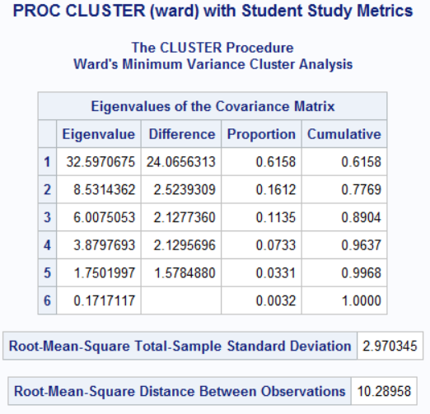
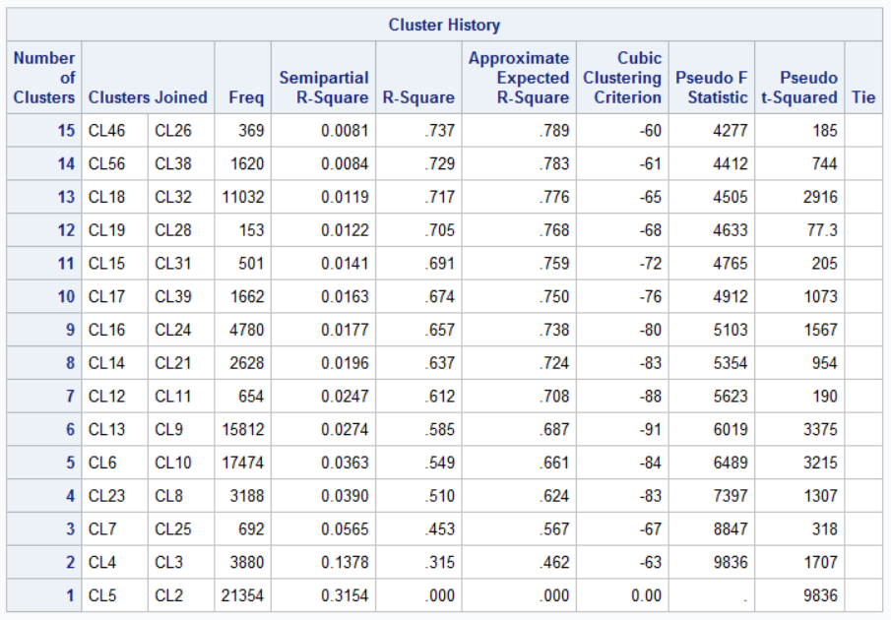

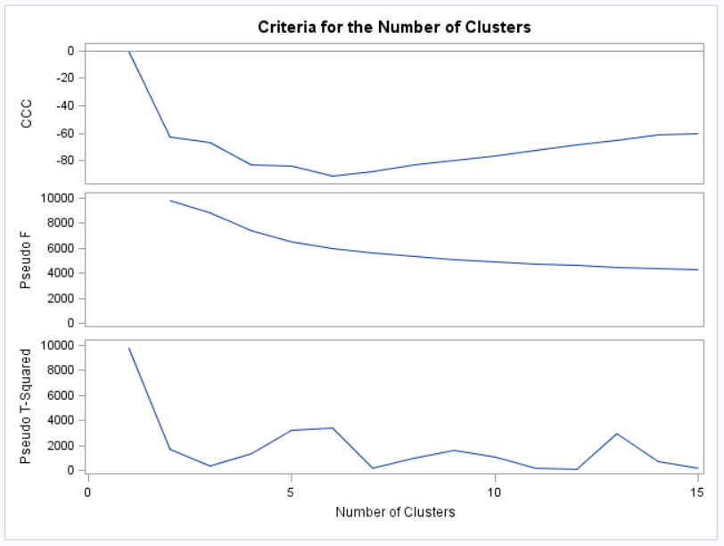

Proc GLM – Study Habits
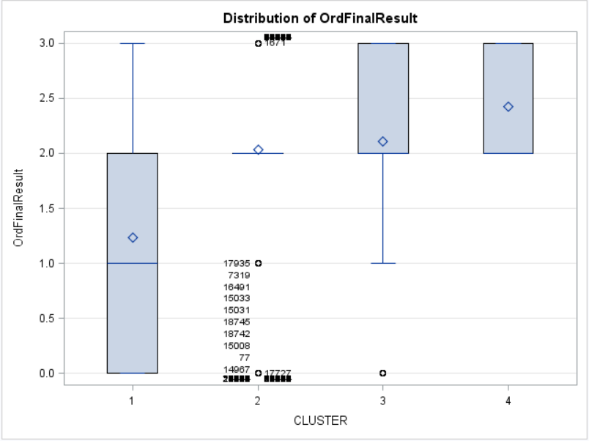

Project Data - Schema
